

Foundations of Programming

Assignment No.: 22
PROBLEM STATEMENT: Write a menu driven program in C to perform various string operations using in-built functions.

OBJECTIVE:

- To understand the concept of strings in the C programming language.
- To learn how to use built-in string functions for string manipulation.
- To perform operations such as length calculation, copying, concatenation, comparison, and reversal using menu options.
.

THEORY:
In the C programming language, a string is a sequence of characters terminated by a null character ('\0'). Strings are stored in character arrays and manipulated using functions available in the string.h header file.
Common built-in string functions include strlen() for finding the length of a string, strcpy() for copying one string to another, strcat() for concatenating two strings, and strcmp() for comparing two strings.
A menu driven program allows the user to select different operations from a list of options. Based on the user’s choice, the corresponding string function is executed. This approach makes the program interactive and easy to use.

PLATFORM: Linux

ALGORITHM:
Step 1: Start
Step 2: Declare variables
- char s1[ ], s2[ ], s1copy[ ]
- int choice
Step 3: Input first string s1
Step 4: Input second string s2
Step 5: Display menu (1 to 6)
Step 6: Input choice
Step 7: Find length
- len = strlen(s1)
Step 8: Switch(choice)
Case 1: Length
- Print len
Case 2: Reverse
- Copy → strcpy(s1copy, s1)
- For i = 0 to len/2
Swap s1copy[i] and s1copy[len-i-1]
- Print reversed string
Case 3: Concatenation
- strcat(s1, s2)
- Print result
Case 4: Palindrome
- Copy + Reverse s1copy
- If strcmp(s1copy, s1) == 0
Print Palindrome
- Else
Print Not Palindrome
Case 5: Equality
- If strcmp(s1, s2) == 0
Print Equal
- Else
Print Not Equal

Case 6: Substring
- If strstr(s1, s2) != NULL
Print Found
- Else
Print Not Found
Step 9: Default
- Print "Invalid choice"
Step 10: Stop
FLOWCHART:
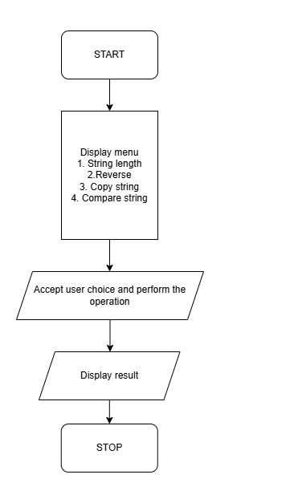
CODE:
#include <stdio.h>
#include <string.h>

int main() {

char s1[10],s2[10];
int choice;

printf("Enter first string : ");
scanf("%s",&s1);

printf("Enter second string : ");
scanf("%s",&s2);

printf("\n");

printf("Menu \n");
printf("1. Length\n");
printf("2. Reverse String\n");
printf("3. Concatenation of strings\n");
printf("4. Check for Palindrome\n");
printf("5. Check if strings are equal\n");
printf("6. Check if second string is a substring of first string \n");
printf("\n");

printf("Enter choice : ");
scanf("%d",&choice);
printf("\n");

int len=strlen(s1);
char s1copy[10];

switch(choice){
case 1:
printf("Length of string = %d\n",len);
break;

case 2:
char s1copy[10];
strcpy(s1copy,s1);
for(int i=0;i<(len/2);i++){
char c=s1copy[i];
s1copy[i]=s1copy[len-1-i];
s1copy[len-i-1]=c;

}
printf("Reversed string : %s\n",s1copy);
break;

case 3:

printf("Concatenated string: %s\n",strcat(s1,s2));
break;

case 4:
if(strcmp(s1copy,s1)){
printf("The string is a Palindrome\n");
}
else {
printf("The string is a Palindrome\n");
}
break;

case 5:
if(strcmp(s2,s1)==0){
printf("Strings are equal\n");
}
else {
printf("Strings are not equal\n");
}
break;

case 6:
if(strstr(s1,s2)){
printf("Substring found in main string\n");
}
else {
printf("Substring not found in main string\n");
}
break;

default:
printf("Enter valid choice");
}

return 0;
}
INPUT: Two strings entered by the user.
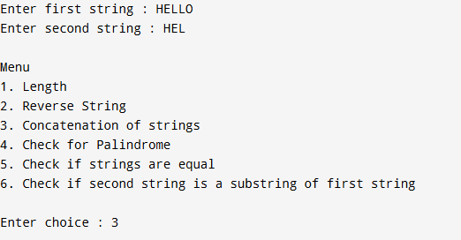

OUTPUT: Displays results of different string operations such as length, copy, concatenation, and comparison.

SAMPLE INPUT:
Enter first string: Hello
Enter second string: World
Choice: 3

SAMPLE OUTPUT:
Concatenated string: HelloWorld
CONCLUSION: Thus, the C program successfully demonstrates different string operations using built-in functions through a menu driven approach, making the program interactive and easy to use.

FAQs:
- What are built-in string functions in C and why are they used?
- What is the purpose of the string.h header file in C programs?
- How does a menu driven program improve user interaction in programming?

